Biology B
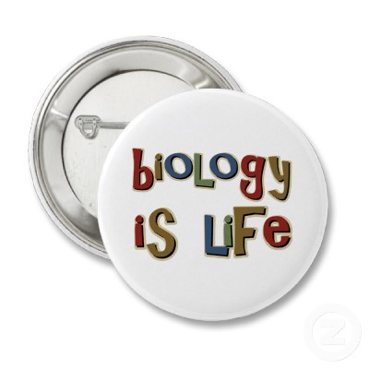
Course Expectations

Mr. Adams
Room M228
Website: www.anoka.k12.mn.us/ahsadams
E-mail: Troy.Adams@anoka.k12.mn.us

COURSE DESCRIPTION:
This course is designed to introduce the concepts of biology. Students will learn about how living things make proteins using nucleic acids, cell division, genetics, evolution, and animal systems. Through a variety of activities including lecture, discussion, group work, videos, and hands-on laboratory investigations students will learn to master the science of life.

GOALS:
- Understand and use the scientific method.
- Develop lab skills and lab techniques used to investigate biology concepts.
- Learn about life processes through the study of ecology, cells, and plants.

Materials
Each day you will need to bring a notebook, a folder, and a pen or pencil. These are the basic essentials to allow you to function in class.

Grading
Your grade will be weighted based on 50% for tests and quizzes, 40% for participation, homework, and labs, and 10% for your Biology A final exam.

Your grades will be calculated on a scale that adjusts every 10%.

A 100-92 A- 91-90
B+ 89-88 B 87-82 B- 81-80
C+ 79-78 C 77-72 C- 71-70
D+ 69-68 D 67-62 D- 61-60
F 59-0

Assignments
Assume that homework is due the next day unless I tell you otherwise. Use your student planners to keep track of these due dates.

YOU are responsible for talking to me and getting assignments you missed. If you missed a daily assignment you will have two days to make it up for full credit. After that time it turns into late work and it is worth half credit.

Success
Use the following list of guidelines
Being on time
Being in class
Turning in your work
Minimize distractions
If you can master these few things you are more likely to be successful not only in this class but in life!

COURSE OUTLINE:
- DNA
  - Structure
  - Replication
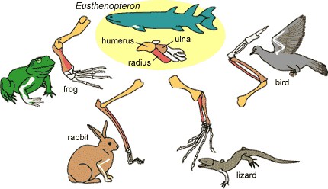
  - Code
  - Protein synthesis

- Genetics
  - Mitosis-Meiosis
  - Mendelian Genetics
  - Mutations
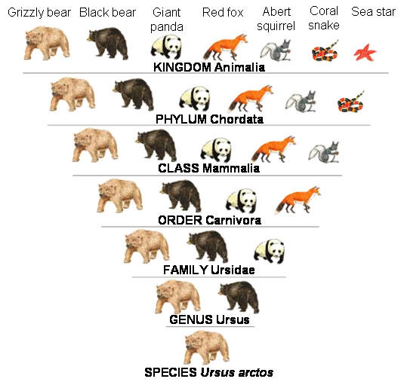
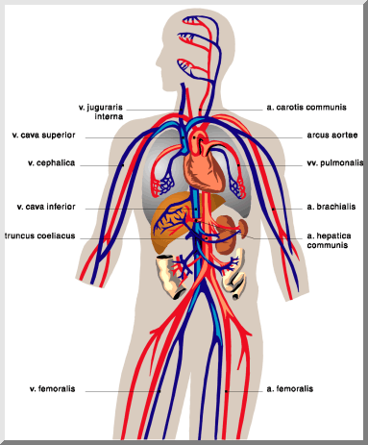
- Processes of Change (Evolution)
  - Evidence for Evolution
  - Natural selection
  - Selective pressures

- Animal body systems
  - Digestion
  - Circulation
  - Respiration
  - Nervous

